User Guide

for

Project and Estimate

## **Project Operations:**

* First of all we need to click on the **Project Operations**.

* A screenshot of a computer

  Description automatically generatedTo create the lead, we need to change the area to **Sales**.

## **Lead:**

* For creating the lead, select the **Leads** from the Sales.

* Then, we will create the new entry for lead by clicking on **New**.

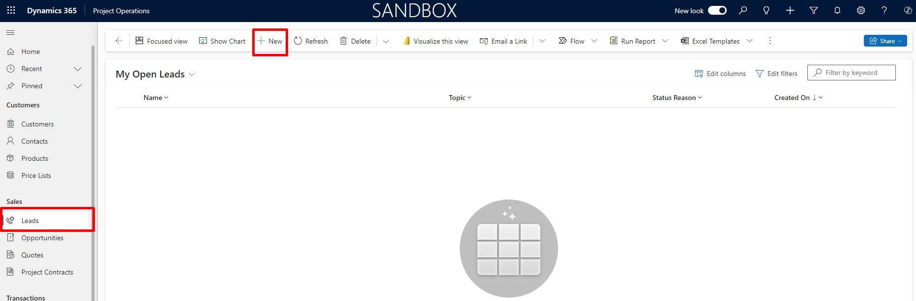

* Then, Enter details to create new Lead record.
* Make sure to enter **Work Based** in Order Type.
* Click on the **Save** button to save the created lead record.
* Click on the **Qualify** button to create opportunity along with contact and account.

Note: After clicking on the Qualify Opportunity will be created automatically along with contact and account.

## Opportunity Line

* In Created Opportunity record, click on the **opportunity lines**.
* Then, click on the **Add New Opportunity Line** to create new opportunity line.

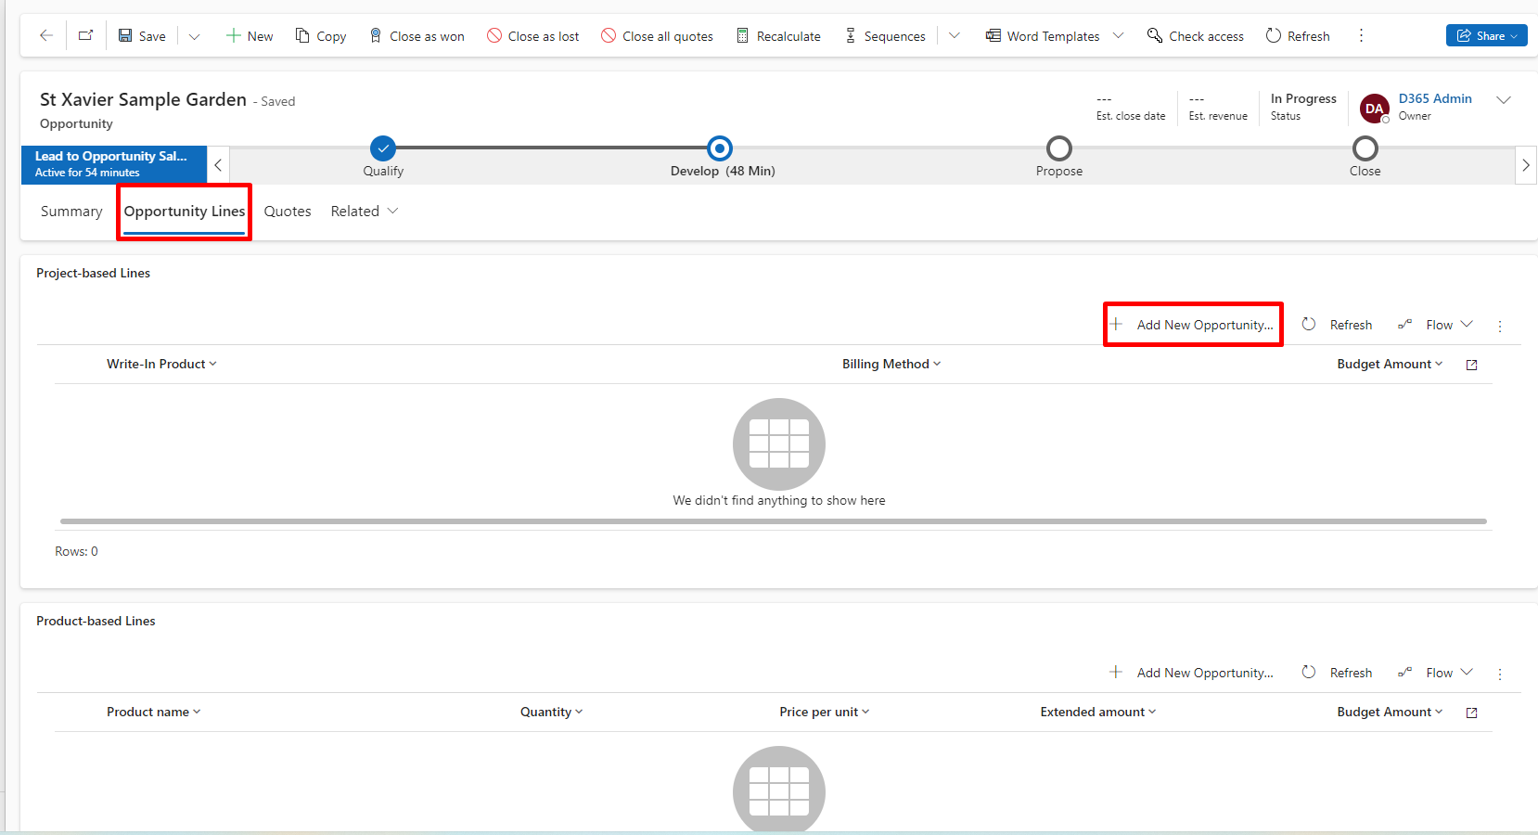

* Add appropriate Name and add **Fixed Price** in Billing Method.
* Click on the **Save** button to save the opportunity line.

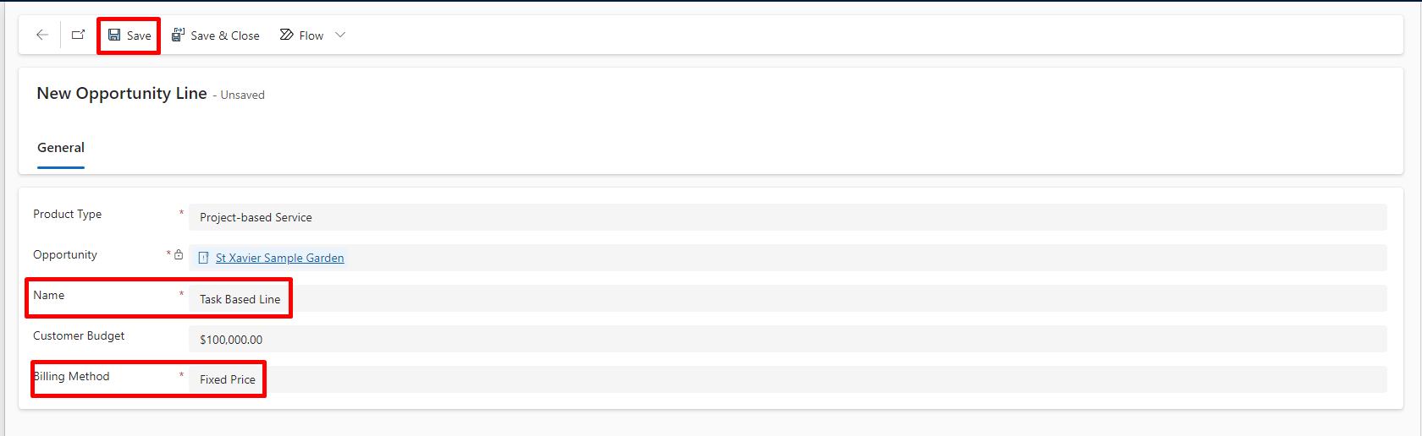

I.e I have created the different opportunity line for the different estimates as shown in below example.

## Quote

* Now, click on the **Quotes**.
* Then, click on the **New Quote** to create the quote from opportunity.

* After clicking on the New Quote, new quote will be created.

* As you can see, Quote lines are automatically created which we have created for opportunity line.
* If we have Expense based Product, then Include Yes for Expense only.
* If we have Material based Product, then Include Yes for Material only.
* If we have Task based Product, then Include Yes for Time only.



